**GENERAL INTEGRATED SCIENCE– UNIT 3**

**TASK 3 – Nutrient Cycle Investigation**

**NAME: _____________________________________ WEIGHTING: 12% %**

**DATE: _______________________________________ MARK: ____ /44 =**

**Part 1: Take-home planning (20 marks)**

Background information.

The cycling of nutrients both on-land and in the ocean is crucial for life to flourish. Without proper cycling of nutrients, life cannot be sustained.

The activities of humans in the past 150 years have led to more **carbon dioxide** being released into the atmosphere, and more carbon dioxide dissolving in the ocean. When carbon dioxide dissolves in water, it makes an acid called **carbonic acid**. An increase in carbon dioxide in the ocean will therefore make the ocean more acidic, a process called **Ocean Acidification**. The ideal pH level for fishes is between pH6.6 to pH7.4 whereas the ideal pH level for aquatic plants is between pH6 to pH9.

Aquatic plants photosynthesise under water. When fish produce carbon dioxide through cellular respiration, the aquatic plants can then take in that carbon dioxide to make oxygen. The oxygen is then reused by fish, and the cycling of nutrients continues. But what happens to this balanced cycle when extra carbon dioxide dissolves in the ocean?

Your task is to plan a scientific investigation that determines the impact of **increasing the amount of fish** in a fish tank on the **pH level** of the water in a tank that contains 5 plants.

Your plan must include:

* An introduction covering the following:
* What is photosynthesis and cellular respiration and, how do the processes cycle nutrients.
* What activities have led to an increase in carbon dioxide levels in the atmosphere and oceans and how.
* Explanation on how does ocean acidification affects aquatic life.  *(6 marks)*
* A hypothesis. *(2 marks)*
* The Independent and Dependent variables– specified. *(2 marks)*
* Controlled variables – all specified and explained. Also include how to minimise the effect of variables that are beyond your control. *(3 marks)*
* An equipment list. *(1 marks)*
* A step by step method of how to carry out your investigation which would include the following:
* Type of fish and aquatic plants to be used.
* Length of time for experiment.
* A risk analysis if needed or any ethical considerations.
* A description of how the data would be analysed and the type of graph that would be used to present your results. *(6 marks)*

NOTE: your experiment will not be carried out, it is only **theoretical**. Therefore, you can use materials you may not find in the lab and, there are no limits on materials and time.

**Part 2: In-class Validation (24 marks)**

Animals produce carbon dioxide when they respire. Plants can then use this carbon dioxide in photosynthesis to produce oxygen. In 2019, more people are becoming concerned about the rising amount of carbon dioxide in the atmosphere and the rise in deforestation – a combination that could lead to too little oxygen in the atmosphere.

A scientist decided to model this concept. She wanted to know what would happen if all of the plants on Earth were gone but people remained. Would we really perish?

To model the impact of removing plants from the planet, the scientist set up two fish tanks. One has 10 fish and 10 plants. The other tank had 10 fish and no plants. The scientist knew that the fish would produce carbon dioxide when they respired, but with no plants to recycle this carbon dioxide, what would be the impact on the water, and then ultimately the fish?

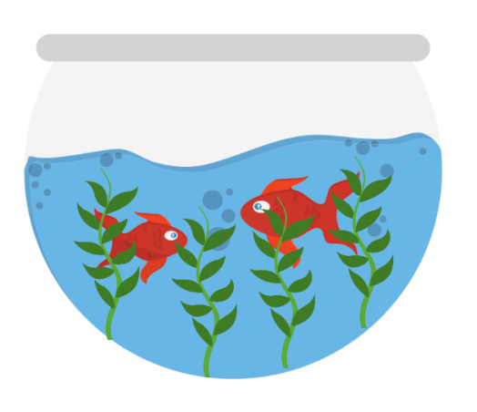Below is a representation of the scientists experiment:

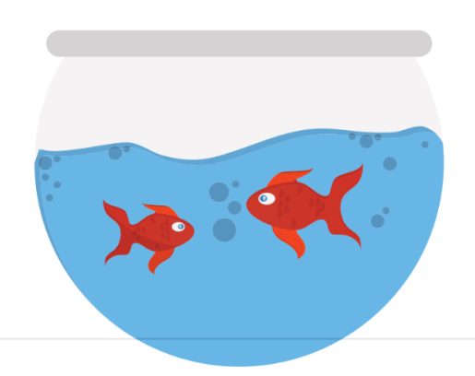

**Tank 1**

**Tank 2**

**Tank A**

The data collected from her experiment is presented in the table below:

|  |  |  |
| --- | --- | --- |
|  | **pH of tank water** | |
| **Day** | **Tank 1 (plants + fish)** | **Tank 2 (fish only)** |
| 5 | 7 | 7 |
| 10 | 7 | 6.5 |
| 15 | 7 | 6 |
| 20 | 7 | 5.5 |
| 25 | 7 | 5 |
| 30 | 7 | 4.5 |
| 35 | 7 | 4 |

1. Using the graph paper provided, graph these results (6 marks)
2. Analyse any trends present in your graph (3 marks)

______________________________________________________________________________________________________________________________________________________________________________________________________________________________________________________________________________________________________________________________________________________________________________________________________________________________________________________________________________________________________________________________________________________________________________________________

1. Choose two of your controlled variables and explain why they needed to be controlled. (4 marks)

__________________________________________________________________________________________________________________________________________________________________________________________________________________________________________________________________________________________________________________________________________________________________________________________________________________________________________________________________________________________________________________________________________________________________________________________________________________________________________________________________________________________________________________________________________________________________

1. What conclusion can be drawn from the data for this experiment? (2 marks)

________________________________________________________________________________________________________________________________________________________________________________________________________________________________________________________________________________________________________________________________________

1. Explain whether this was a valid experiment. Use evidence to support your answer. (2 marks)

________________________________________________________________________________________________________________________________________________________________________________________________________________________________________________________________________________________________________________________________________

1. State 2 ways in improve the reliability of this experiment and explain why they would work.(2 marks)

________________________________________________________________________________________________________________________________________________________________________________________________________________________________________________________________________________________________________________________________________

1. Using your understanding of abiotic factors and biotic factors to explain what impact are human having on the carbon cycle. Include in your answer how these changes are going to impact on the other nutrient cycles. (5 marks)

____________________________________________________________________________________________________________________________________________________________________________________________________________________________________________________________________________________________________________________________________________________________________________________________________________________________________________________________________________________________________________________________________________________________________________________________________________________________________________________________________________________________________________________________________________________________________________________________________________________________________________________